BIRLA INSTITUTE OF TECHNOLOGY & SCIENCE, PILANI (RAJASTHAN)
SECOND SEMESTER 2004-2005
AAOC C321 Control Systems
Comprehensive Examination (Closed Book)
Part- A and B

Date 07-05-2005 Total Time: 3 Hrs Max Marks: 120
Part- A

Time: 1 hr. Maximum Marks: 30
NOTE: (i) Number of questions: 25
(ii) Number of blanks : 30
(iii) Each blank carries one mark

Name: ID No: Sec. No.

Q. 1 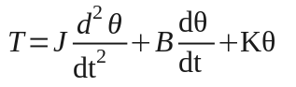 is the torque equation of the rotational system where J, B, K are constants. The system described by this equation is ______________________. (Time variant/Time invariant)
Q.2 When a system satisfies the property of homogeneity and superposition, it is classified as ______________________(linear /nonlinear).
Q.3 The friction coefficient of a mechanical rotational system is analogous to ______________ in force current analogy.
Q.4 For the signal flow graph shown in figure Q.4, the numbers of pairs of non-touching loops two taken at a time are _________and forward paths are ________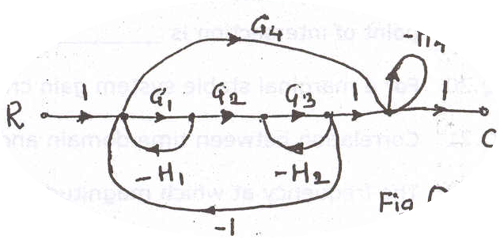
Fig Q.4
Q.5 A unity negative feedback system has open loop transfer function G(s) = 50/(τs +10). The sensitivity of the closed loop system to small changes in τ (τ=0.001) at ω= 0 rad/sec is ____________.
Q.6 In a two-phase servomotor, R/X ratio is ___________than the conventional induction motor.
Q.7 The type of signal output you get from synchro error detector is_____________________.
Q.8 Pneumatic relay works as an_________________________ in Pneumatic systems.
Q.9 The basic unit of hydraulic system is _______________.
Q.10 For the bellows shown in figure Q.10, A is the area of cross section of the bellows, C, its capacity and k the stiffness constant. The transfer function X(s)/P(s) is _______________.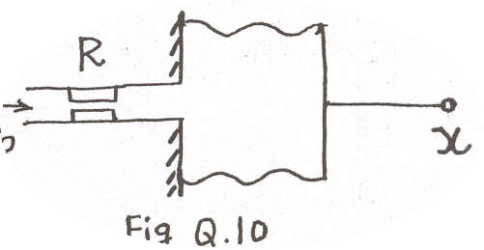
Q.11 An oscillatory response in which the amplitude decreases with time is a _______________damped response.
Q.12 The open loop transfer function of a system is (s+1)/[s²(s+2)]. Type of the system is ________ and steady state error due to two unit ramp input is________________.
Q.13 The unit step response of second order underdamped system exhibits the peak overshoot of 15%. If the magnitude of the input is doubled, the peak overshoot will be ____________%.
Q.14 Impulse response of a system is c (t) =1-e^{-t}. Transfer function of this system is__________.
Q.15 The roots of the characteristic equation are the poles of the _______________ loop system.
Q.16 The open loop transfer function of system 1 and system 2 are K/(s+2)⁴ and K/(s+2)⁵ respectively. System_____________ is more stable.
Q.17 A unity negative feedback system, having two open loop poles and no open loop zero is critically damped for some value of gain. If gain is increased further the system will exhibit__________________damped response.
Q.18 The open loop transfer function of a system is 3(s+3)/[s²(s+7)]. The number of asymptotes is __________ and the location of centroid is _________.
Q.19 The polar plot of 1/(1+4s) ³ crosses the imaginary axis at ___________ and frequency at the point of intersection is ____________.
Q.20 For a marginal stable system gain cross over frequency _______ phase cross over frequency.
Q.21 Correlation between time domain and frequency domain breaks down when ξ is _________.
Q.22 The frequency at which magnitude of [G(jω)H(jω)]is becomes one is known as___________.
Q.23 The frequency response of G(jω)H(jω) cuts the negative real axis at -0.5 +j 0. The gain margin of the system is __________________db.
Q.24 The slope of the Bode plot (asymptotic) within region 5 <ω < 10 for open loop transfer function G(s) = 100/ [s(s +10) (s+20)] is ________________.
Q.25 If there are 3 zeros and 2 poles enclosed by the s-plane contour in clock wise direction, the net number of encirclements of the origin by the q(s)-plane contour is ________in_________________ direction.

Birla Institute of Technology and Science, Pilani

Second semester 2004-2005

AAOC C321: Control Systems

Comprehensive Examination (Part B)

Date:07.05.2005 Time: 2 Hrs MM: 90

Q.1 The schematic diagram of a servo system is shown in fig. Q.1. The two-phase servomotor develops a torque in accordance with the equation
T_{M} = K₁ V_{c} – K₂ 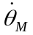
where K₁ = 0.001 N-m/volt
K₂ = 0.2 N-m /rad/sec
The other parameters of the system are:
Load inertia (J_{L}) = 100 kg-m²
Coefficient of load friction (B_{L}) = 5 N-m/rad/sec.
Motor to Tachometer gear ratio 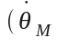/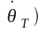= 1/1
Motor to synchro gear ratio/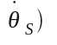= 1/1
Sensitivity of synchros (K_{s}) = 10 volts/rad
Tachometer constant (K_{t}) = 2 volts/rad/sec
Ampilifier gain (K_{A}) = 20 volts/volt
The motor inertia and friction are negligible.

(i) Draw the block diagram of the system
- Determine the transfer function, θ_{L}(s)/ θ_{R}(s).
(iii) Determine the sensitivity of the system for changes in K_{A} for 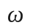=1rad/sec
[15]
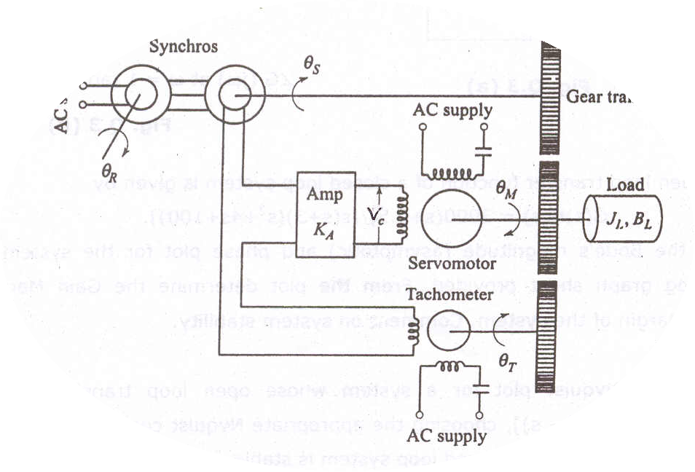
Fig. Q. (1)

PTO

Q.2. A field controlled DC motor is used to control the speed of a load. DC motor parameters are as given below:
R_{a} = 1Ω, R_{f} = 200 Ω, L_{f} = 1 mH, Power = 10 kW, Speed = 950 rpm,
K_{T} = 20 N-m/ Field Ampere, motor inertia and friction are negligible.

Design an appropriate system by selecting suitable components (give justification) from the following list if the minimum load torque is 500 N-m. Load inertia and friction are 200 kg-m² and 20 N-m/rad/sec respectively. [15]
List of components:
- A DC reference source (V_{r} ) to set the speed
- DC amplifier with gain (K_{A}) = 10 V/V
- AC amplifier with gain (K’_{A})= 50 V_{rms} / V_{rms}
- Gear train with a reduction ratio of 1: 2
- Gear train with a reduction ratio of 1: 5
- AC tachometer with a sensitivity (K_{s}) = 0.5 V_{rms} /rad/sec
- DC tachometer with a sensitivity (K_{t}) = 0.2 V/rad/sec
(a) Draw the block diagram of the system
(b) Obtain the transfer function, ω_{L}(s)/V_{r}(s)
(c) Find the steady state value of output if there is sudden change in input of 2 units

Q.3 For the system whose block diagram is given in fig Q. 3(a)
(i) Determine the transfer function G(s), Where frequency response plot of G (jω) is given in fig Q.3 (b)
(ii) Determine the value of position error coefficient, velocity error coefficient and parabolic error coefficient
(iii) Draw root contours of the system on your answer sheet for k = 0.125 and 0.25. [20]

C(s)
+
R(s)
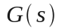
−
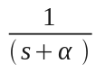

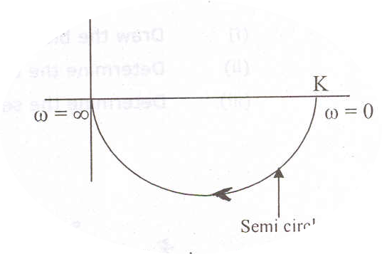
Fig. Q.3 (a)


∠G (jω) at ω = 1 rad/sec is - 45°
Fig. Q.3 (b)

Q.4 The open loop transfer function of a closed loop system is given by
G(s)H(s) = 3000(s+0.5)/[s(s+3)(s²+4s+100)].
Draw the Bode’s magnitude (asymptotic) and phase plot for the system in the semi-log graph sheet provided. From the plot determine the Gain Margin and Phase Margin of the system. Comment on system stability. [20]

Q.5 Sketch the Nyquist plot for a system whose open loop transfer function is K(s+3)(s+4)/[s (3 - s)], choosing the appropriate Nyquist contour. Determine the range of K for which the closed loop system is stable. [20]

